|  |  |
| --- | --- |
| **Fundamentals for IT Professionals III**  Diploma in CSF/FI  Year 2 (2021/22), Semester 5 | Week **1** |
| **1** hour |
| **Activity Week 1 – Career Assessment & Job Search** | |

**OBJECTIVES**

* Understanding yourself – career assessment
* Contact job search strategies

**ACTIVITIES**

1. Career assessment

* Explore / review your
  + RIASEC

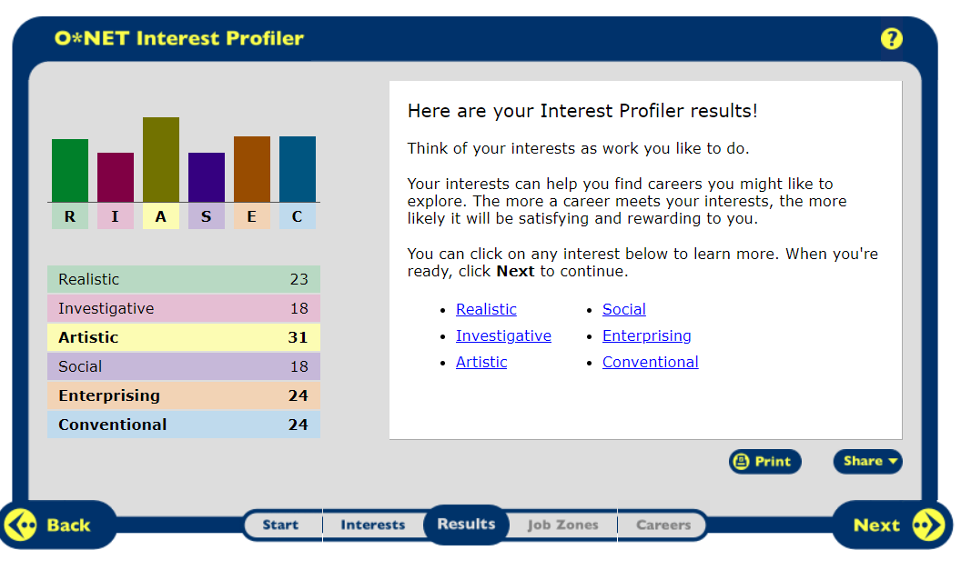

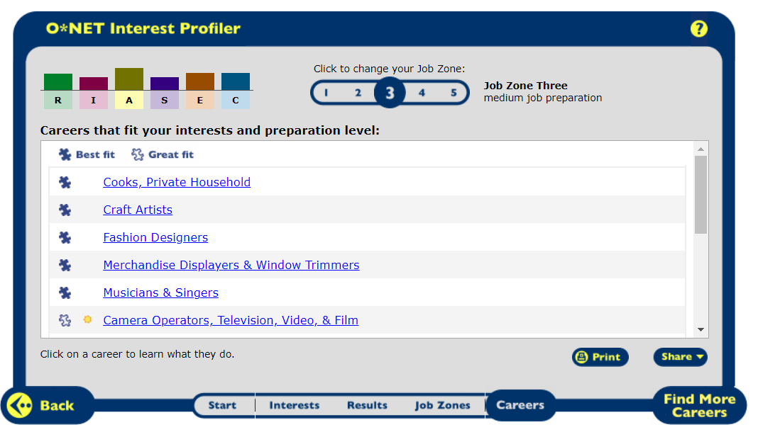

* + MBTI (16 Personalities)

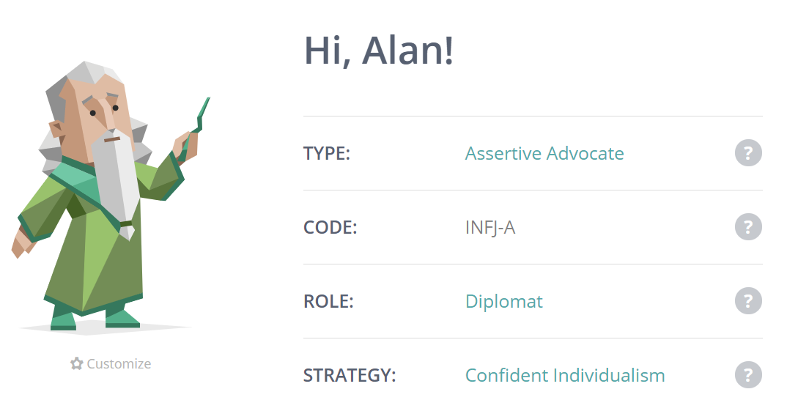

* Discuss your RIASEC / MBTI with your tutor
  + How does it compare to your that done during your Year 1? More artist type career had been fitting for me.

1. Update your ePortfolio
   * Skills and knowledge that you have acquired thus far
     + Indicate which semester it was acquired & to group the skillsets under each semester section
   * Awards that you have achieved (if any)
   * Courses that you have attend (if any)
   * Events and activities that you have organized/attended
   * Any other relevant information

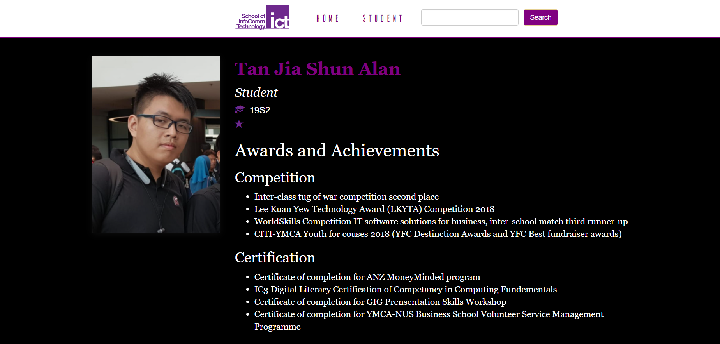

1. Update your LinkedIn profile to include your newly acquired skills and knowledge.

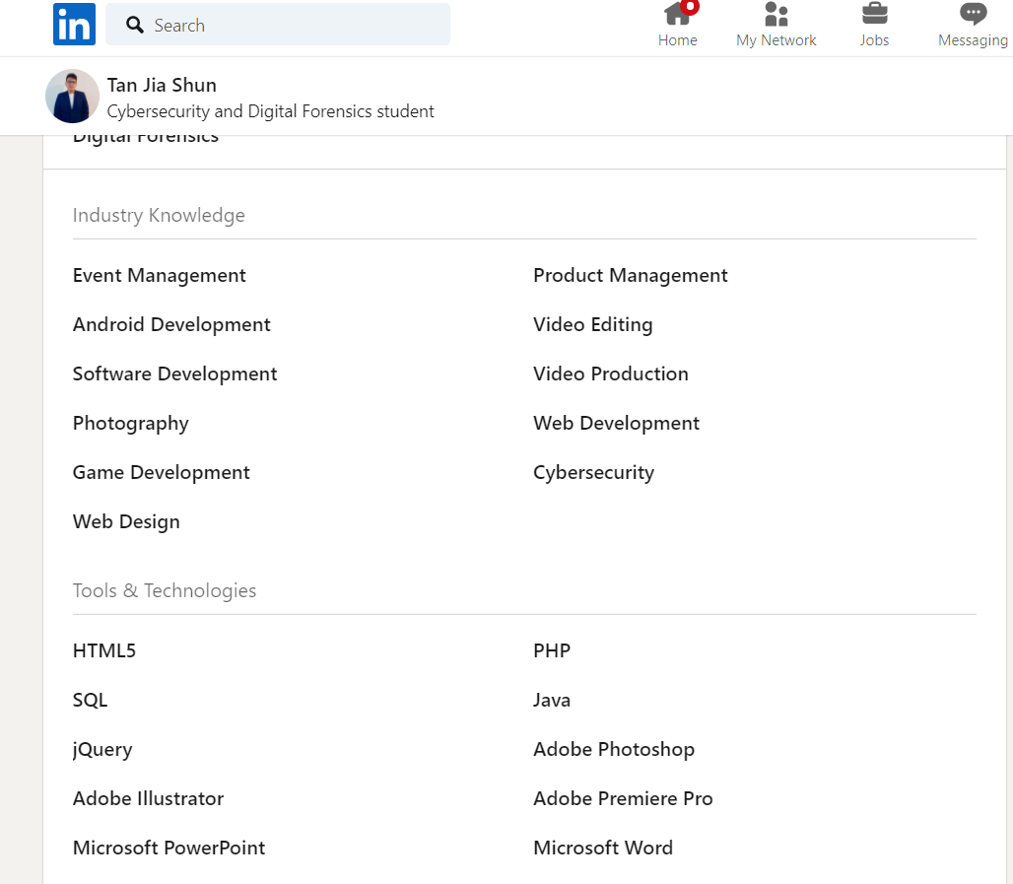

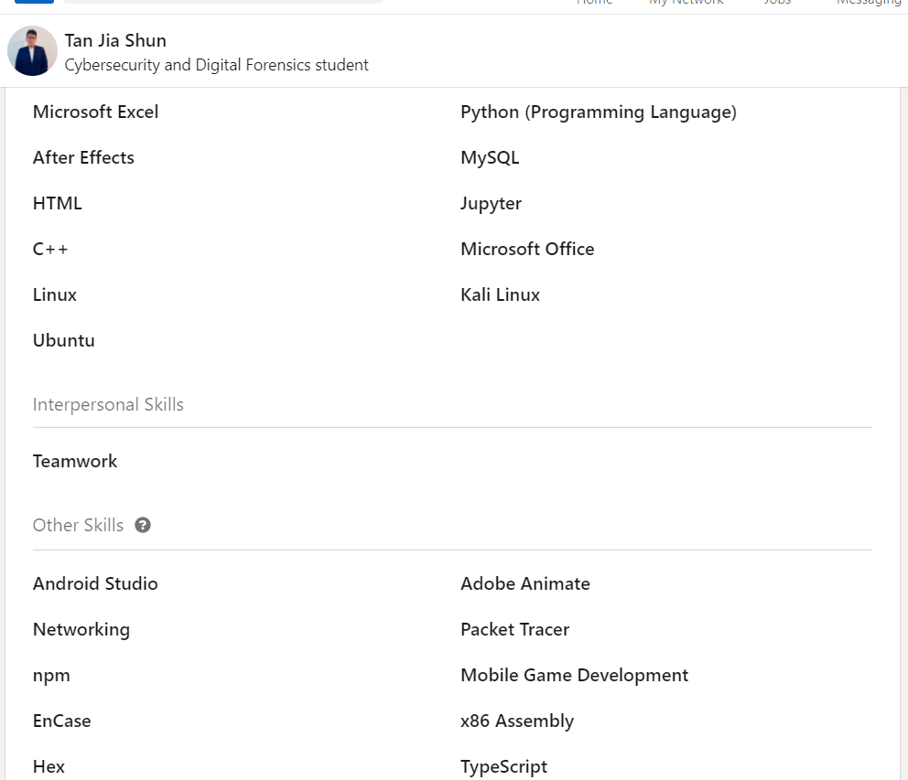

4. Labour Market & Job Search

* Activate your Straits Times (ST) Online account and research on the labour market and job opportunities in the area of IT. Identify at least one article and include in your submission. https://www.straitstimes.com/singapore/courts-crime/cyber-security-experts-warn-of-facebook-messenger-upgrade-scam
* Shortlist three IT-related job advertisements. Choose one to write your CV and cover letter.

1. <https://www.jobscentral.com.sg/job/security-support-engineer-no-exp-is-welcome-cybersecurity-j3w88h68lmcpkbx3dv7?iPath=JRKCVT>
2. <https://www.jobscentral.com.sg/job/it-security-analyst-j3p69362b8np4xdhw12?iPath=JRKCVT>
3. <https://www.jobscentral.com.sg/job/it-security-specialist-mnc-bank-contract-j3s3575vzycst6f2gxs?iPath=JRKCVT>

5. Submission

* Submit your completed activity to MeL:

Groups🡪 *<student group>* 🡪Group Discussion Board 🡪 Week 1 Submission